Work-case 5

Готували матеріал студентки Гоголь А., Трегуб О.

**1. При роботі з персональним комп’ютером дуже часто виникає необхідність підключати периферійне обладнання. На прикладі принтера та флешки опишіть який механізм має ОС Linux для роботи з ними.**

1. Adding a printer to the system

When choosing a printer, you first need to see if it is supported by your OS.

First, plug in the printer, turn it on, and then connect the USB cable from the printer to the computer. First, you need to check if your system detects the printer automatically. Modern printers support a universal data exchange protocol, and it is supported in new versions of distributions. To do this, open the Settings utility, then Devices and Printers. Next, click the Add printer button. The system will search for printers and then display a list of found devices. If you find a printer, select it and click the Add button. Fine-tuning the ubuntu printer can be done using the Print Options item.

2. Search and installation of drivers

If the first method did not work, you will have to try to find a driver for this printer on the Internet. Even if the printer worked, but it has a built-in scanner, without drivers you will not be able to make it work.

The driver can be found using Google or on the official website. To search for drivers, you can also use the Vendor ID of your printer, which can be viewed using the lsusb command:



To find out which of the entries belongs to the printer, you can run the command with and without the printer connected, and then compare or search the output for the name of the printer. Download the Linux deb version of the driver and the ScanGear scan utility. Then extract the package archives and install the packages. The developers deliver in the archive not only the package, but also the installation script, so after unpacking it is enough to run the .sh script:





After installation, the utility will ask to connect the printer. Select the USB connection option, press Enter, and then type the number of the found printer and press Enter again. The utility will register the printer in the system and now you can use it. Similar actions should be taken for the scanning utility:





Now you can run something to print. To start the scan utility, use the command:



In order for Linux to be able to work with a flash drive - write, copy files from it, delete, then you need to perform a mounting operation. Description of this operation in the next task.

**2. В чому суть операції монтування, для чого вона використовується та як?**

In Linux, mounting is the process of mounting an additional file system on top of the current file system on the computer. A mount point is a directory to access your data (files and folders) stored on your disks.

Using the example of mounting a flash drive, we will explain the mounting operation:

The first thing you need to do after you have connected the flash drive is to find out the name of its file in the system. In Unix, all devices have their own files, and it is through these files that the system and software interact with them.

Files of flash drives and other data storage devices are located in the /dev directory. Devices are numbered alphabetically sda, sdb, sdc, sdd, etc. Since the flash drive is connected last, it will have an uppercase letter. For example, sdb or sdc. The name sda ​​belongs to the hard disk. You can, of course, simply browse the contents of the /dev/ directory, but this method is unreliable. We will use the fdisk utility.

Connect the flash drive and do:



As you can see, here we can view detailed information about the device. File name, partition list, partition table format, partition list. And the most important thing for us is the partition size and its file system.

We create a folder for mounting:



Now we mount the flash drive using the mount command:

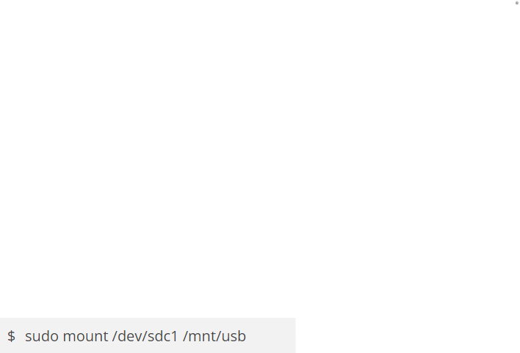

If you know the file system of the flash drive, it is better to specify it using the -t option. FAT is most often used.



The installation is carried out from the superuser, but if it is necessary to monitor the flash drive, anyone can specify the users option:



By default, the owner of the files on the flash drive during mounting is set to root, so if you want to work with the flash drive through the file manager, you will need to run it with superuser rights or immediately mount the flash drive in linux so that the owner is your user. To do this, specify the group and id of your user in the uid and gid options:



You can make sure that the flash drive is connected by looking at the contents of the directory in which we mounted it:



After you finish working with the flash drive, don't forget to unmount it. Because otherwise the data may not be saved or the file system of the flash drive may be damaged:



**3.В чому різниця при роботі з периферією у ОС Linux та ОС Windows?**

Linux peripherals like hard drives, CD-ROMs, printers are considered files whereas Windows, hard drives, CD-ROMs, printers are considered as devices. In Linux everything is a file. Devices like printer, mouse, keyboard etc. are files. In MS Windows, devices like Printers, CD-ROM, and hard drives are represented as drive letters( G: H:). In Linux, there are represented as files.(All device files reside in the directory /dev/).